Translation telephone



In this project you will learn how **few-shot prompting** is used to improve the responses from language models.

You will also see the risks of **semantic drift** when using generative AI to work with information.

*This project assumes you already understand the basics of how language models work.   
  
You will understand this project better if you do the “Language Models” worksheet before this one.*

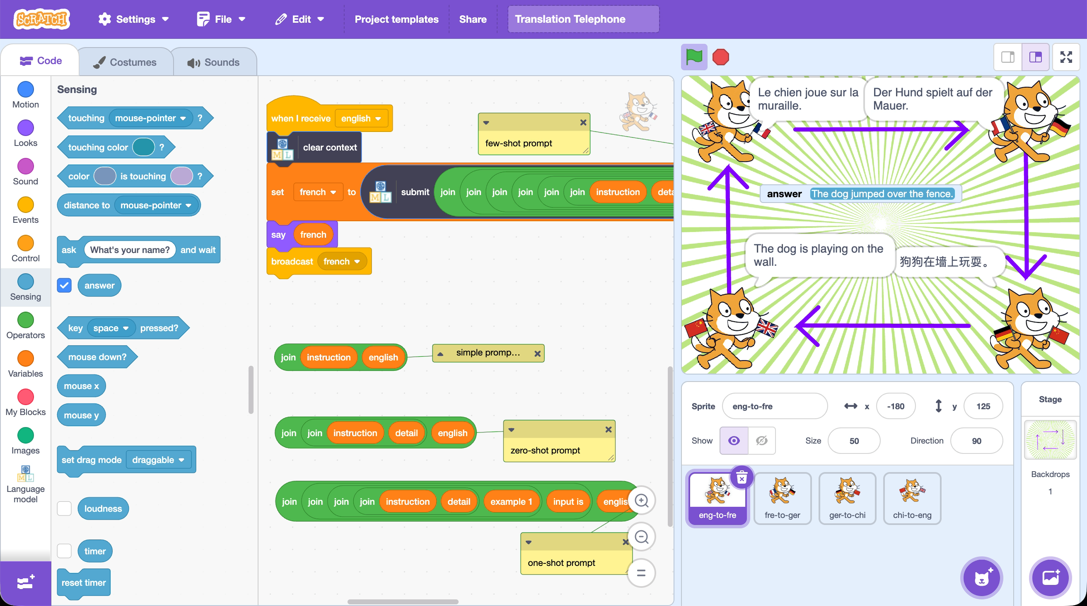

This project worksheet is licensed under a Creative Commons Attribution Non-Commercial Share-Alike License

http://creativecommons.org/licenses/by-nc-sa/4.0/

If you are under the age of 13, please only use a small language model with supervision from a trusted adult.

Generative AI can sometimes generate text that isn't nice or appropriate.

1. Go to <https://machinelearningforkids.co.uk/>
2. Click on “**Get started**”
3. Click on “**Log In**” and type in your username and password  
   *If you can’t remember your username or password, ask your teacher or group leader to reset it for you.*
4. Click on “**Projects**” on the top menu bar
5. Click the **“+ Add a new project**” button.
6. Name the project “**Translation Telephone**” & set it to generate text  
   Click **Create**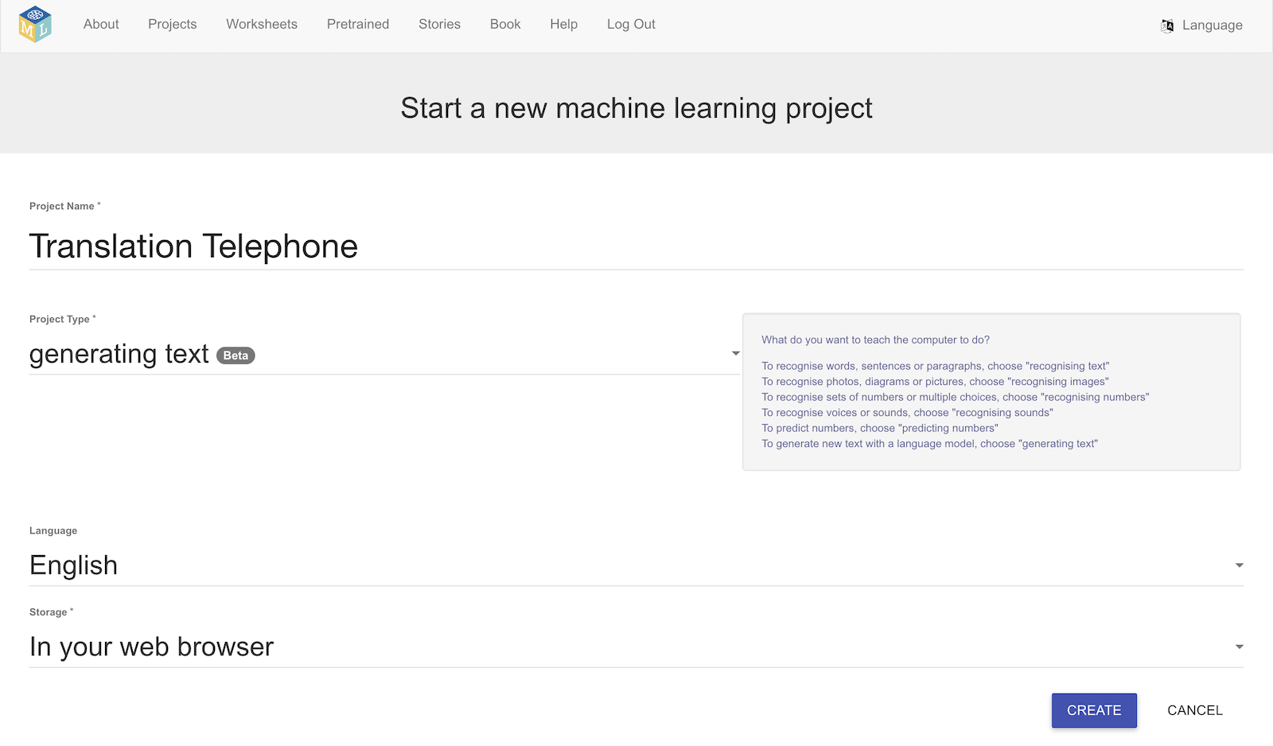
7. You should see your new project in the projects list. Click on it.
8. Click on **Small**, and then click **Next**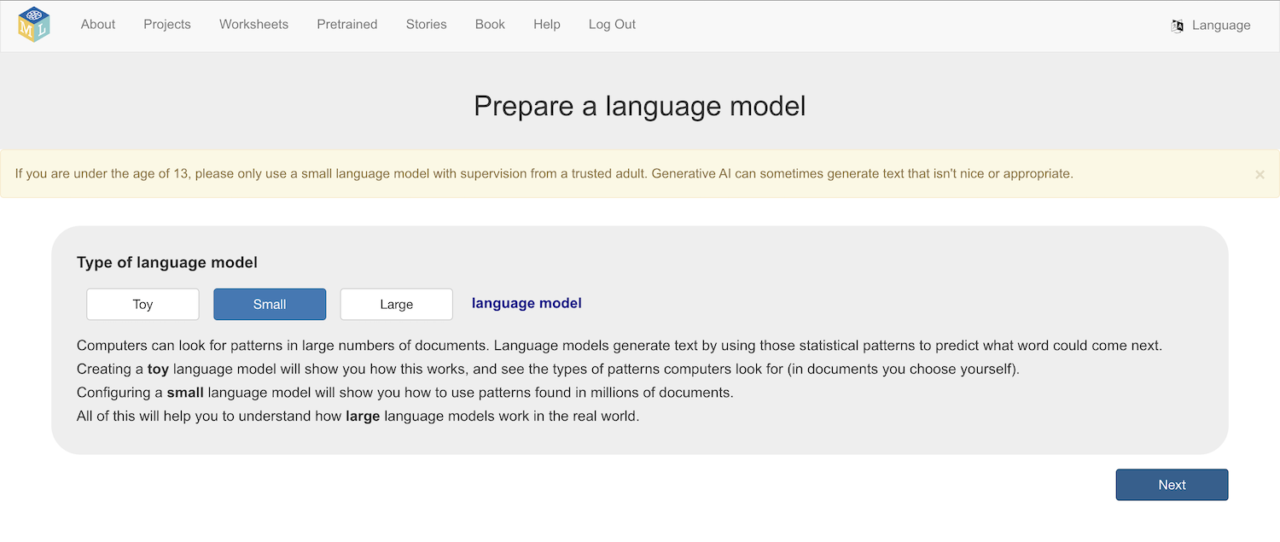
9. Choose a model architecture to use  
   *There are several models to choose from.*   
   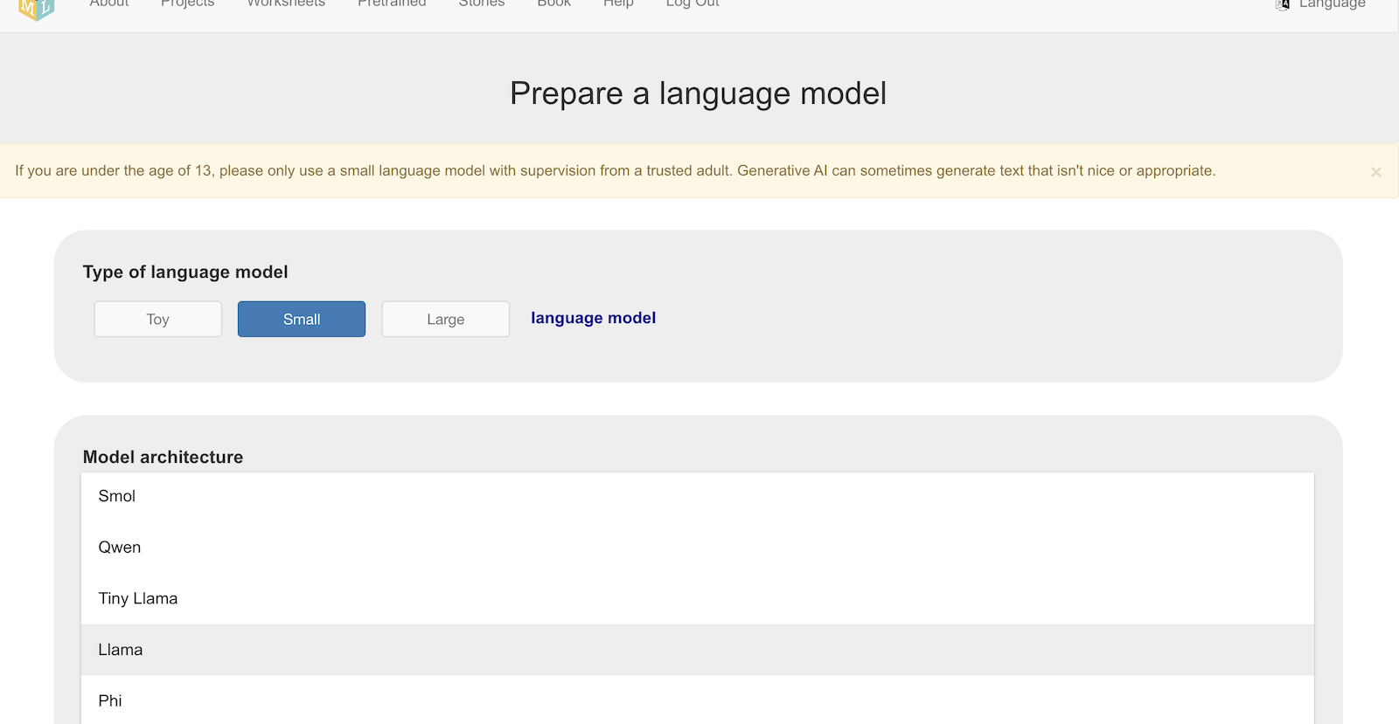  
     
   *Larger and more complex models can generate better text.   
     
   But larger models:  
   * will take longer to download  
   * will need more storage space on your computer  
     
   And more complex models:  
   * will need a faster and more powerful computer to run  
     
   Choosing a different model from other students around you is a good idea as it will let you compare how different models behave.  
     
   For the screenshots in this worksheet, I chose* ***Gemma***
10. Click **Download**
11. Choose **8192** as the context window size, then click **Next**
12. Leave the high temperature and Top-p value, then click **Next**
13. Select **No initial context**, and click **Next  
    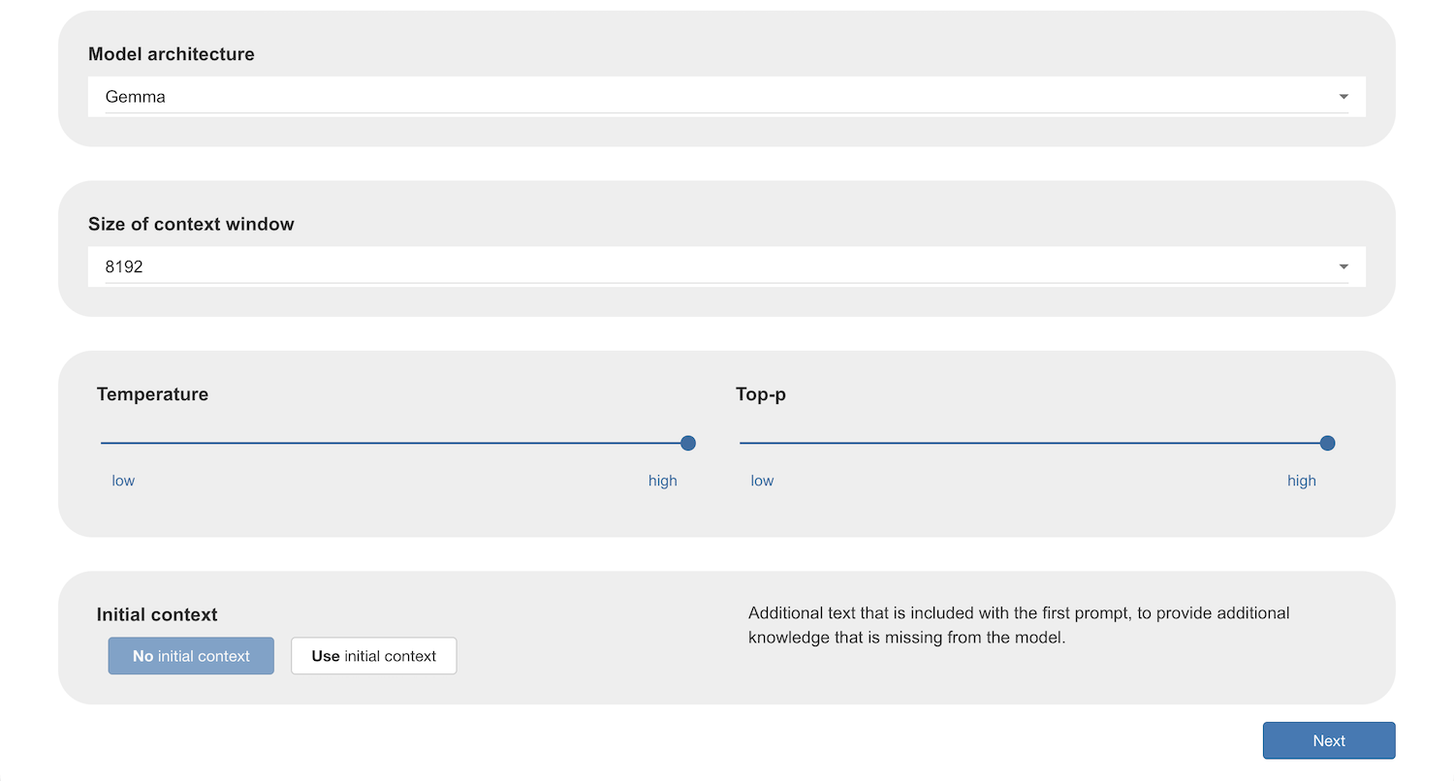**
14. Ask the model a question to verify that it works on your computer  
    *If it doesn’t work, choose a smaller model and/or a smaller context window size, and then try again.*
15. Once it works, click on **Scratch**  
    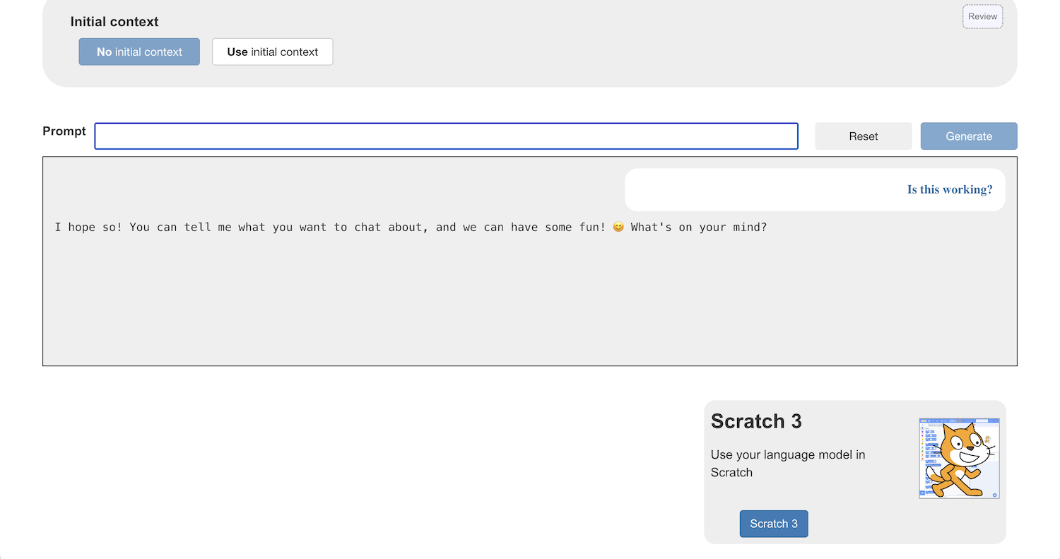
16. In the Scratch window that opens, click on **Project templates**   
    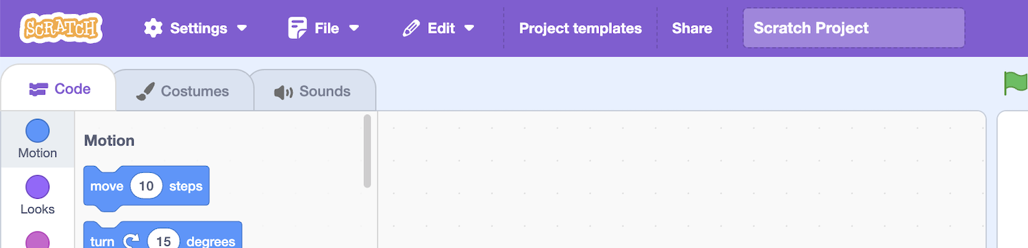
17. Click on the **Translation Telephone** template  
    *There are four Sprites in this template, each one set up to use your language model to translate a sentence from one language to another:  
    * one will translate from English to French  
    * one will translate from French to German  
    * one will translate from German to Chinese  
    * one will translate from German to English  
      
    Once started, this will continue forever. And if they each do this well, the first sprite will be given the same sentence that it got at the start every time.  
      
    The next thing you will do will be add your language model to the template.*
18. Click on the **eng-to-fre** sprite and find **when I receive english**   
    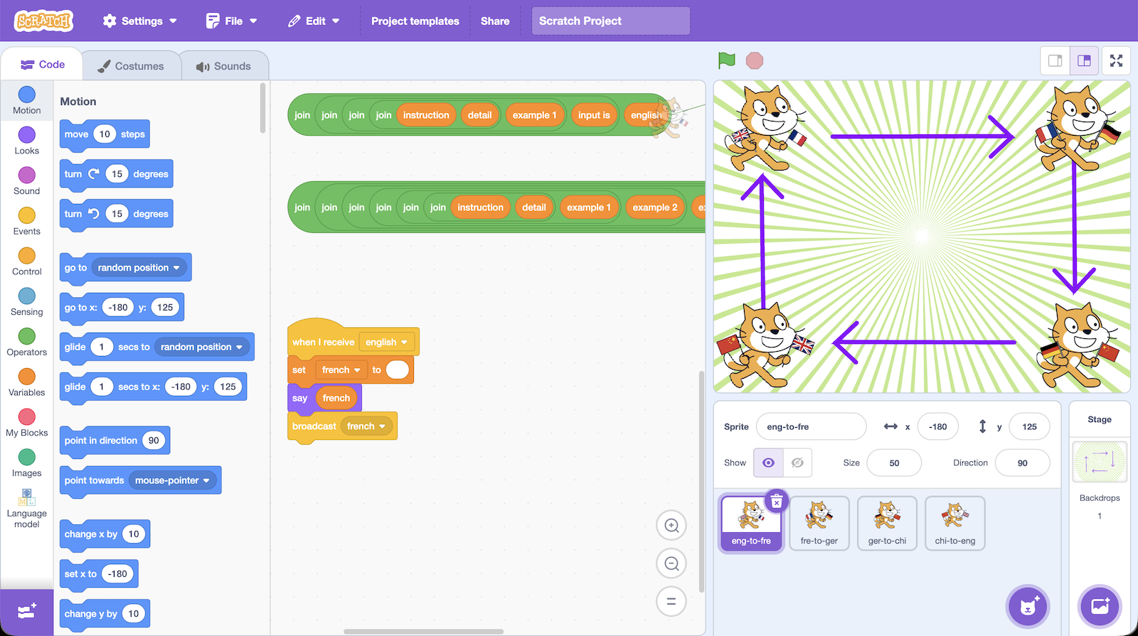
19. Update the code to make it look like this  
    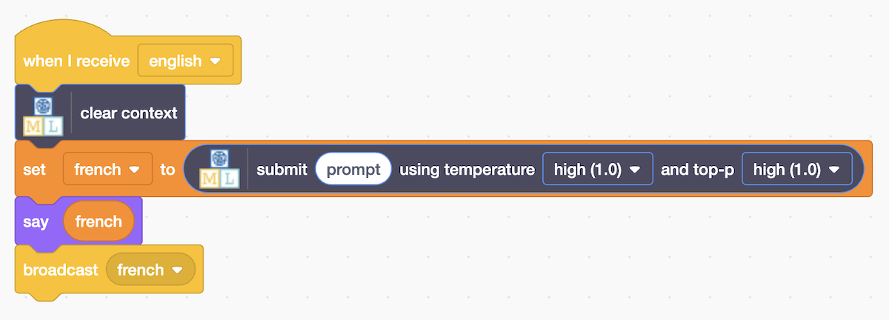
20. Click on the **fre-to-ger** sprite and find **when I receive french**   
    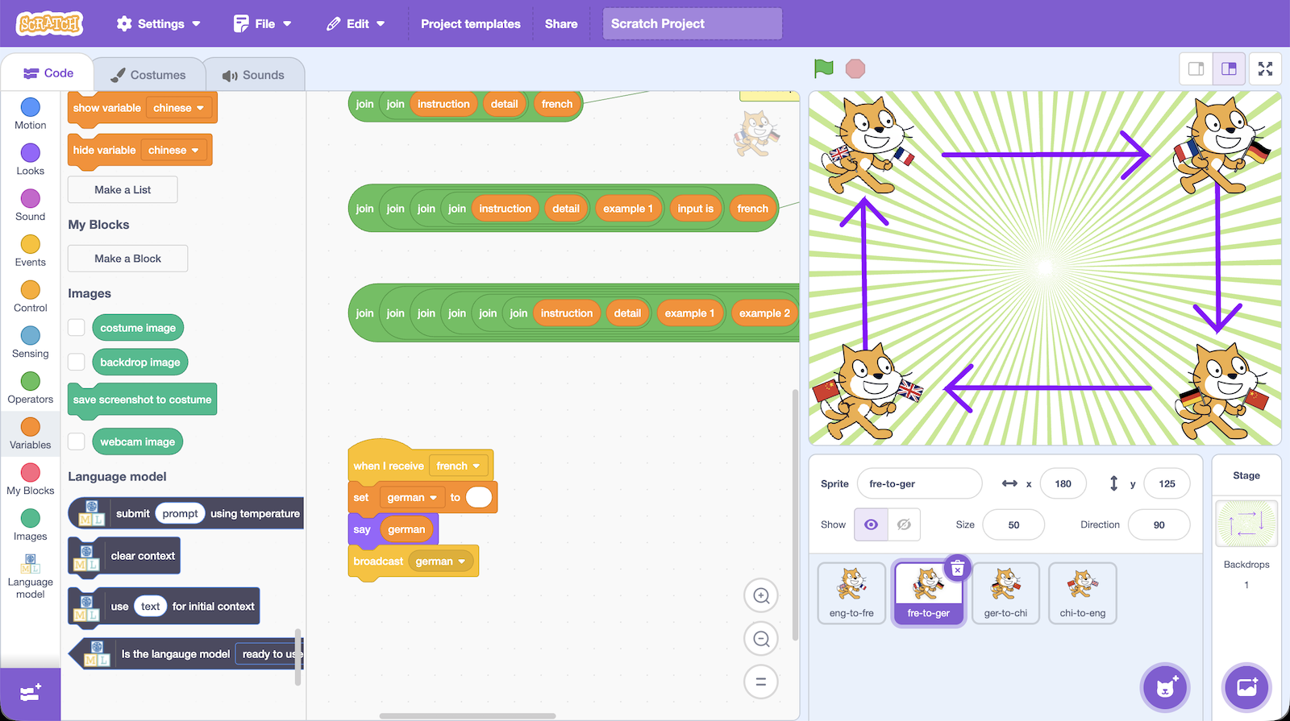
21. Update the code to make it look like this  
    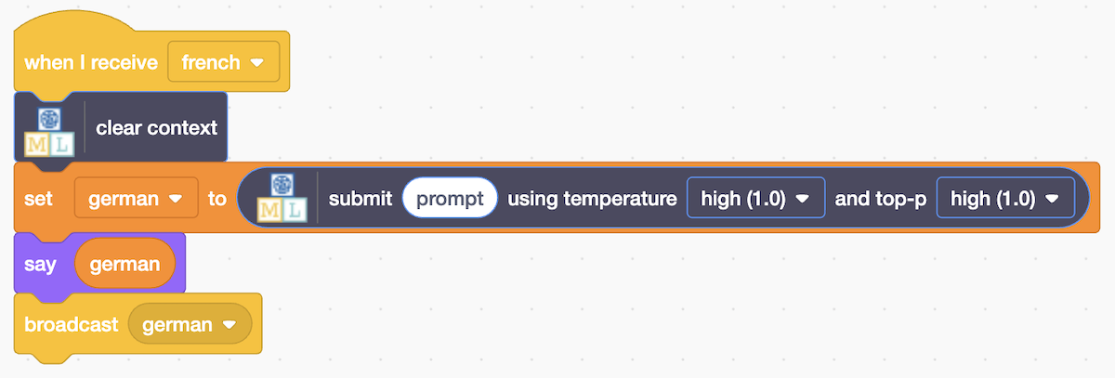
22. Click on the **ger-to-chi** sprite and find **when I receive german**   
    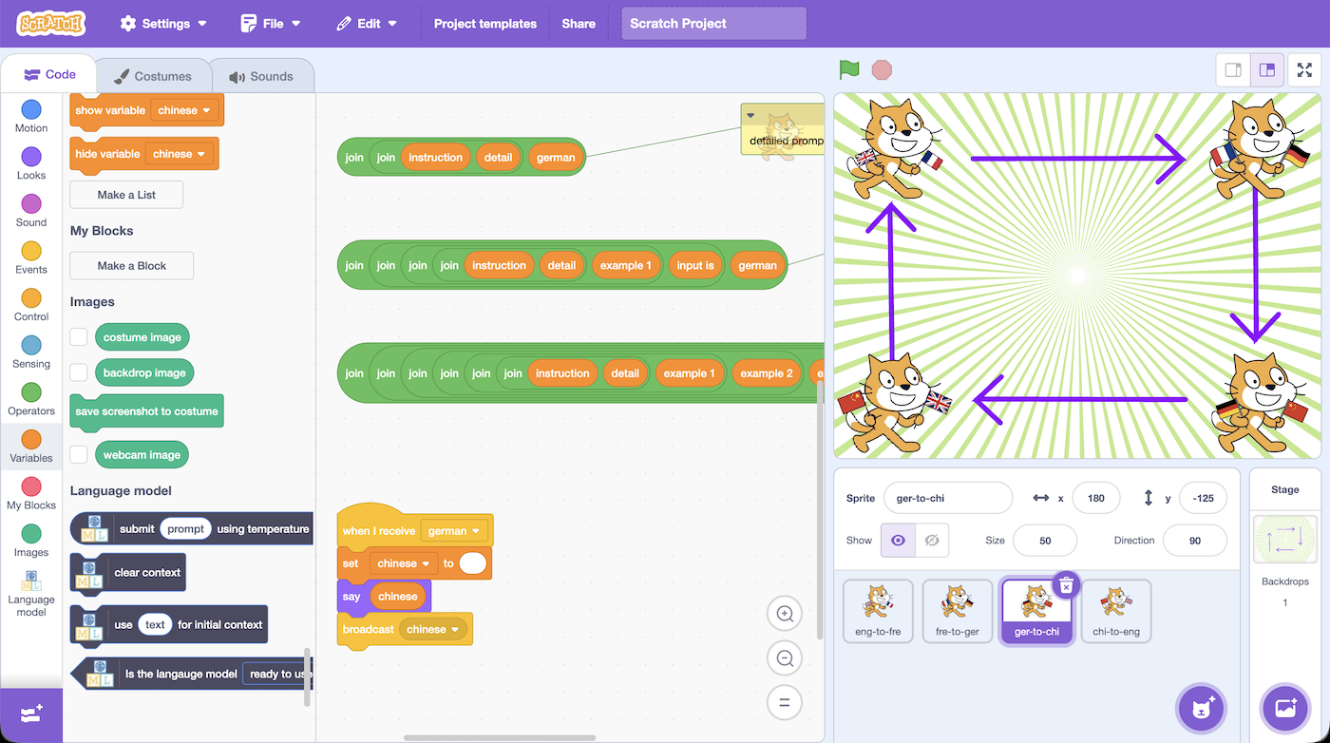
23. Update the code to make it look like this  
    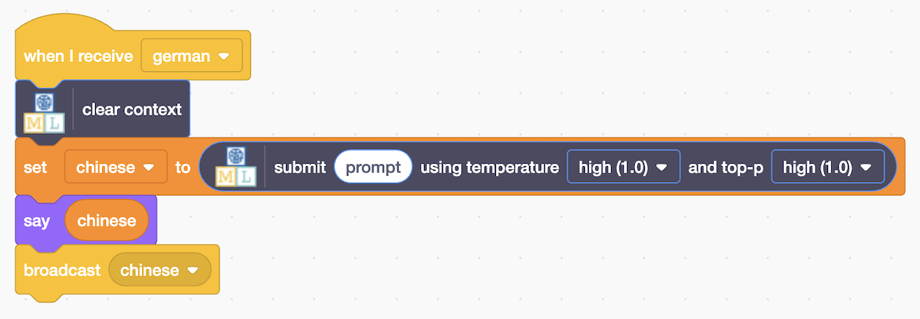
24. Click on the **chi-to-eng** sprite and find **when I receive chinese  
    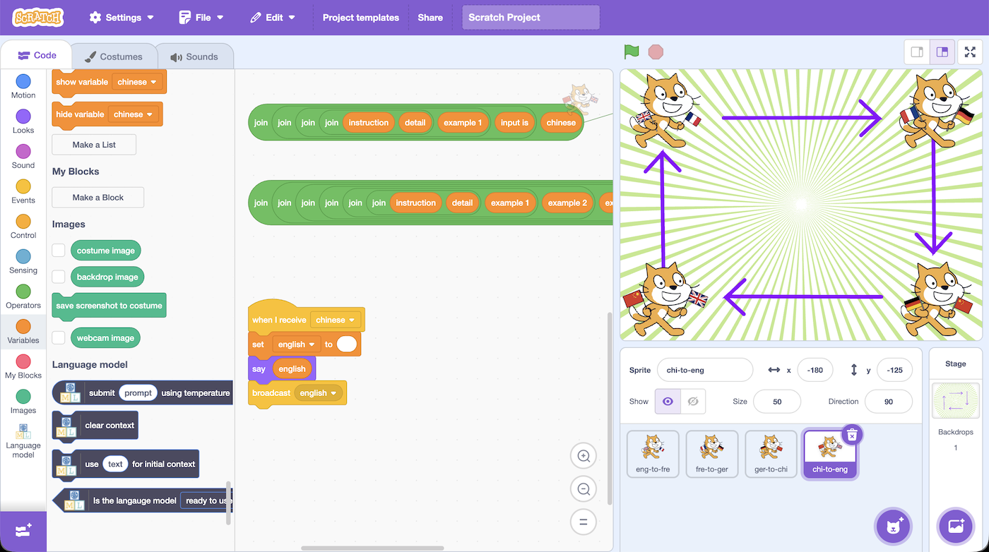**
25. Update the code to make it look like this  
    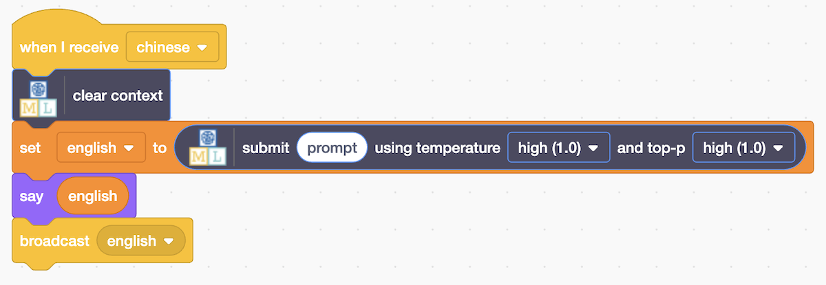
26. Go back to the **eng-to-fre** sprite and find the four sets of green **join** blocks that have been prepared for you   
    *You can try zooming out using the controls in the bottom-right of the code window if that helps you to see it.*  
    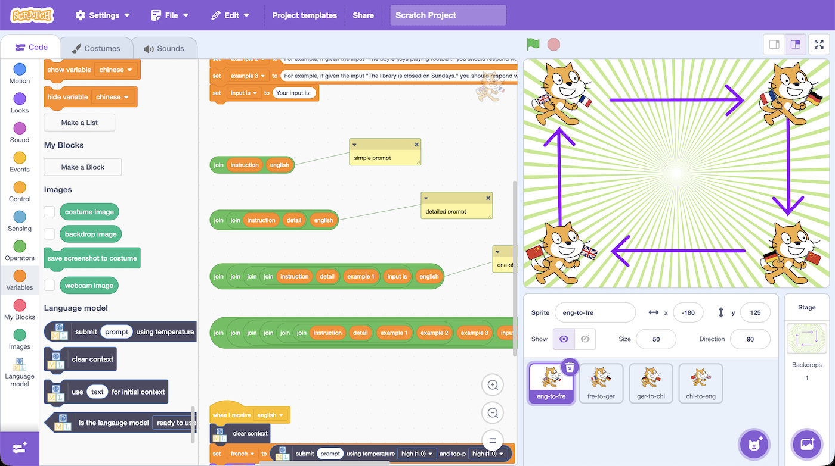  
      
    *Each of these four sets is a different type of language model prompt.*   
      
    *We will start with the easiest example, the* ***simple prompt****That will prompt the language model with something like:***Translate the following English sentence from English to French.  
      
    <YOUR INPUT SENTENCE HERE>**
27. Drag the **simple prompt** into the **when I receive english** code   
    *It should go into the submit block where the text* ***prompt*** *is*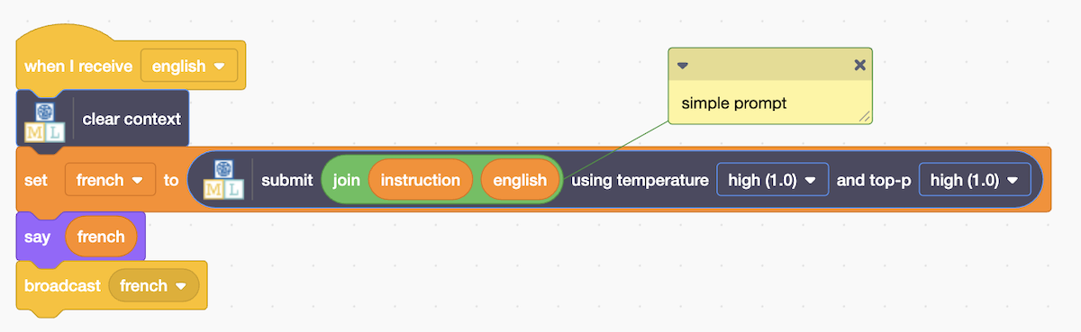
28. Click on the **fre-to-ger** sprite again
29. Drag the **simple prompt** into the **when I receive french** code  
    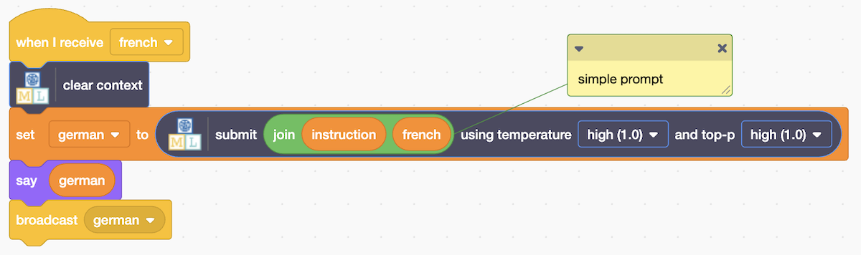
30. Click on the **ger-to-chi** sprite again
31. Drag the **simple prompt** into the **when I receive german** code  
    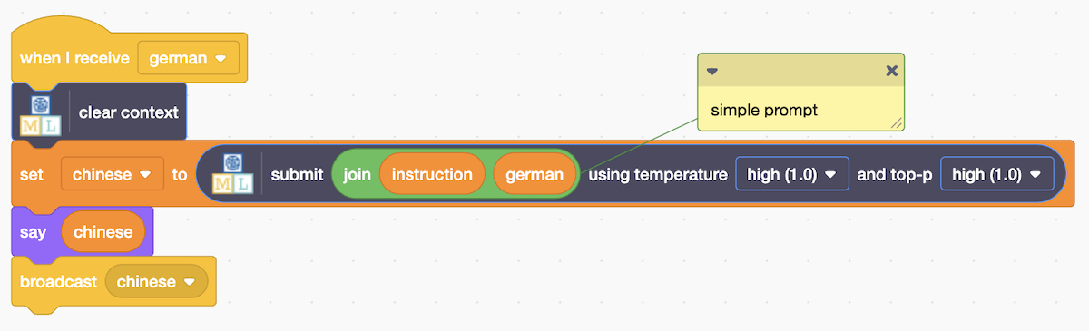
32. Click on the **chi-to-eng** sprite again
33. Drag the **simple prompt** into the **when I receive chinese** code  
    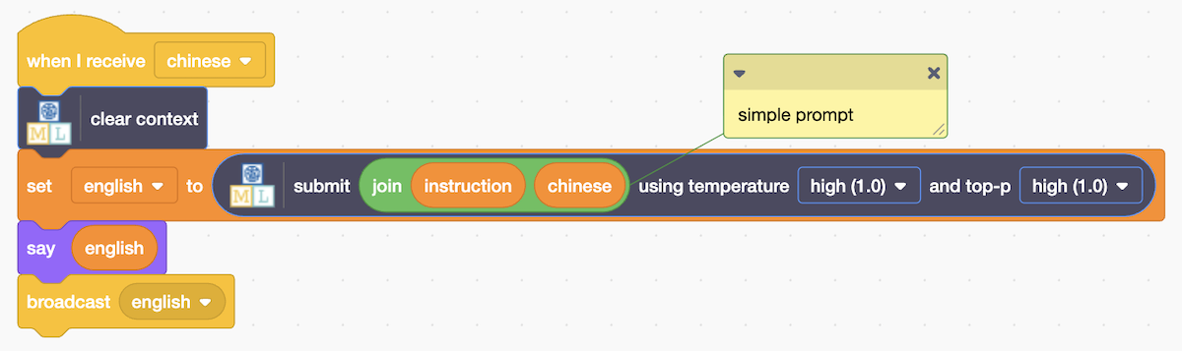
34. It’s time to test! Click on the **Green Flag** to run the project  
    *You might find it easier to see if you click on the full-screen button first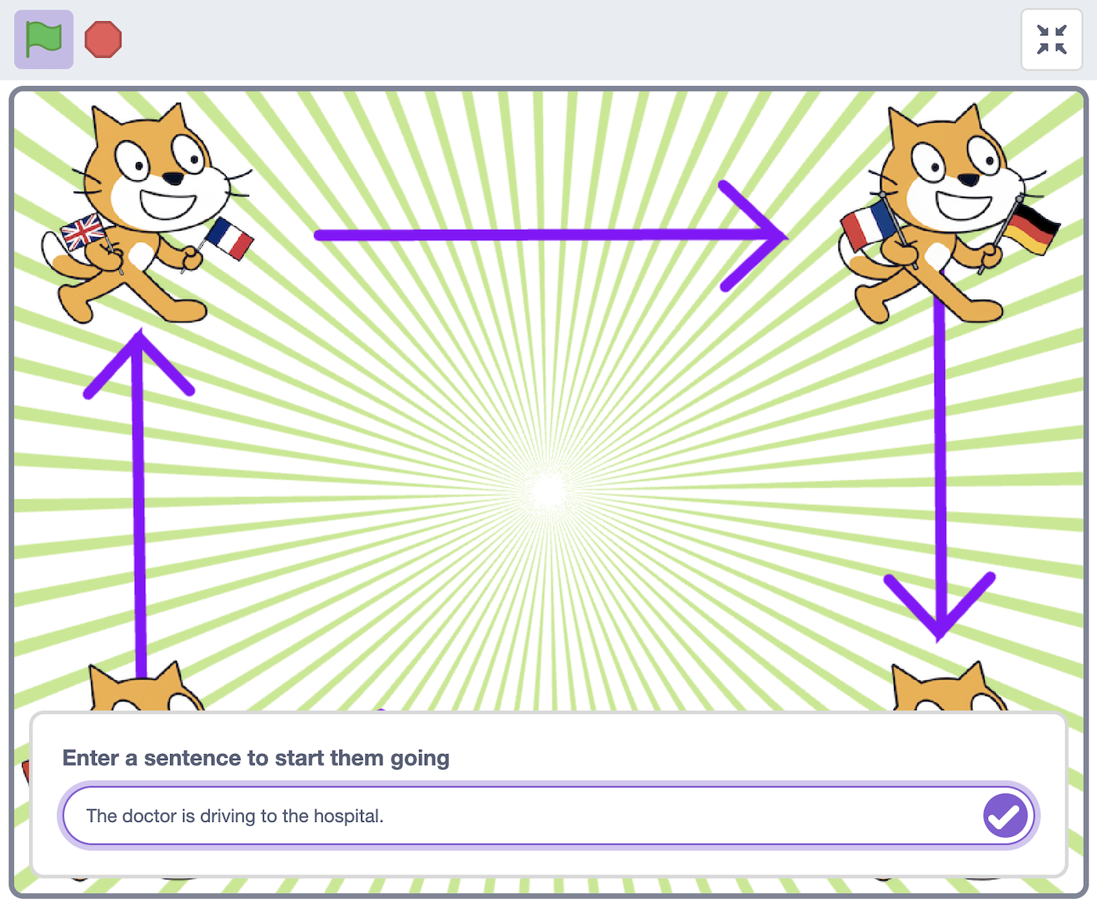 Enter one sentence, ending in a full-stop. In the screenshot, I’ve used   
    “The doctor is driving to the hospital.”  
    You can make up your own sentence – but keep it* ***short*** *and* ***simple****.*
35. What happens when you try that?   
    *You may see the language model reply with more than a translation, which is given to the next sprite to translate, making it get worse.*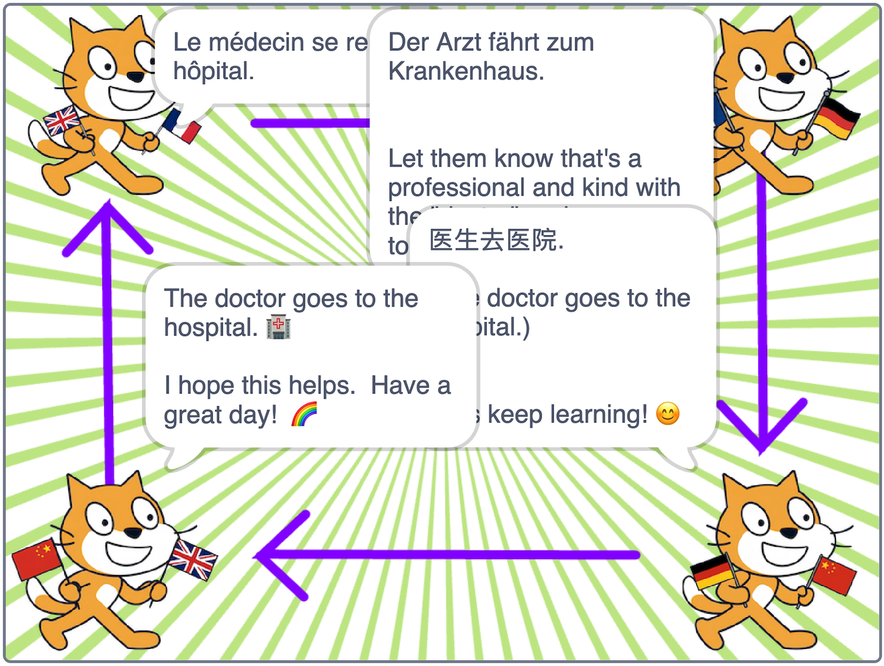  
    *Click on the* ***Stop*** *button when you have seen enough*
36. You didn’t tell the model to respond only with the translation.   
    *How could you get just the translation without the rest of the language model’s explanation?   
    Try experimenting in the model setup page to find a better way to ask.*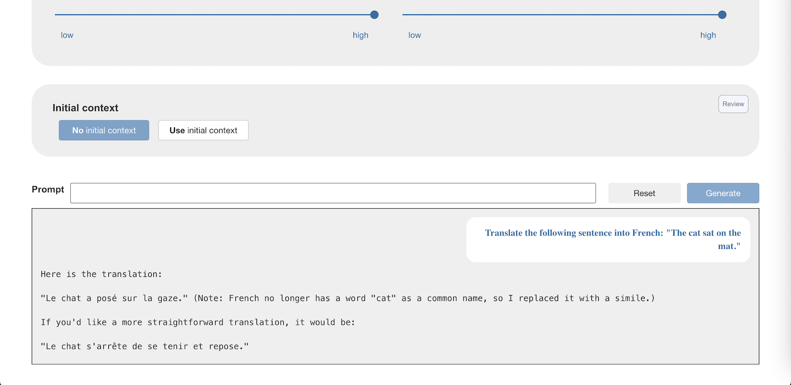
37. Next you will try the **detailed prompt** inyour Scratch project*That will prompt the language model with something like:***Translate the following English sentence from English to French.  
    Respond only with the English translation, don't say anything else.  
    <YOUR INPUT SENTENCE HERE>**
38. Move the **simple prompt** out of each of the sprites  
    Replace it with the **detailed prompt***Make sure that you do this in* ***all four sprites***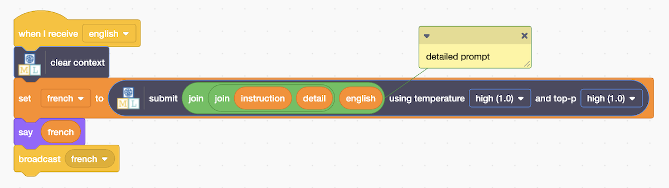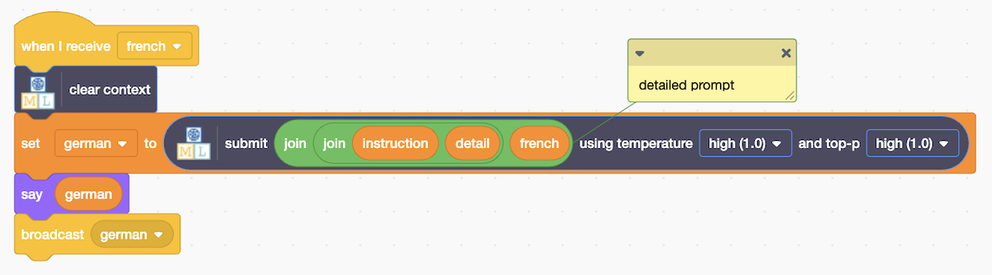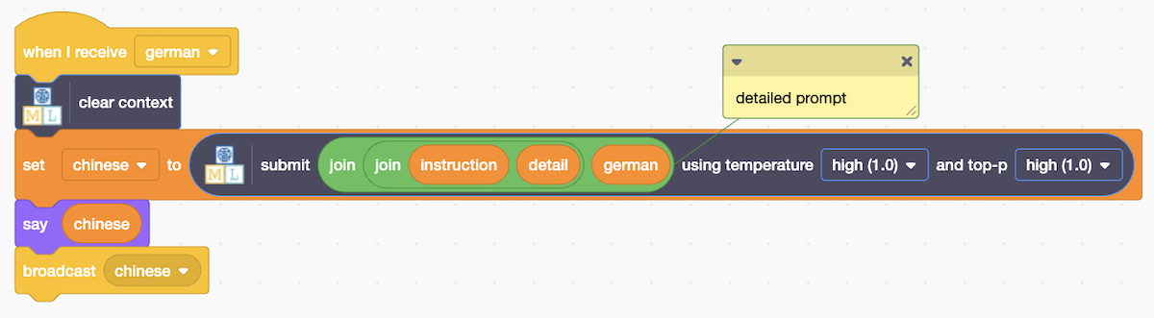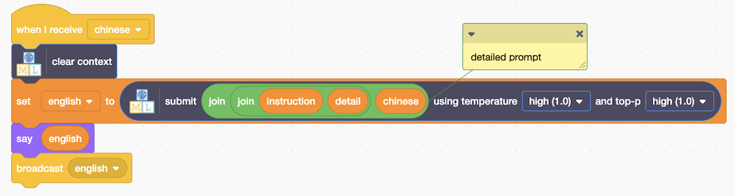
39. Test it again by clicking **Green Flag**. *Does this help?   
    (Remember to click on the* ***Stop*** *button when you have seen enough)*
40. *Some models may work correctly at this point.   
    Other models might still not have correctly understood your instruction*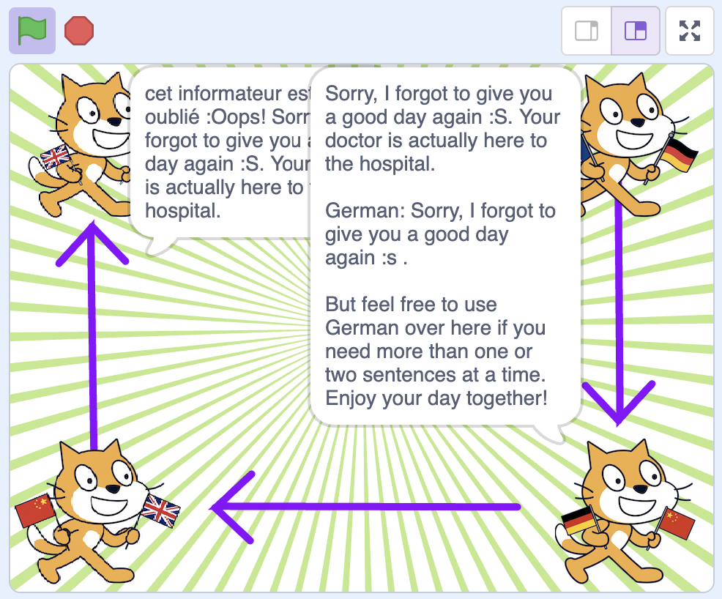
41. Next you will try the **one-shot prompt***That will prompt the language model with something like:***Translate the following English sentence from English to French.  
    Respond only with the English translation, don't say anything else.  
      
    For example, if given the input "The cat sat on the mat." you should respond with only: Le chat était assis sur le tapis.  
      
    <YOUR INPUT SENTENCE HERE>**   
    *Including an example of what you want the model to do can help to get the sort of answers that you want.*
42. Move the **detailed prompt** out of each of the sprites  
    Replace it with the **one-shot prompt***Make sure that you do this in* ***all four sprites***  
    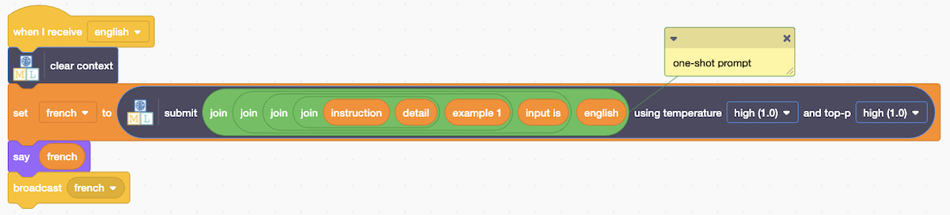  
    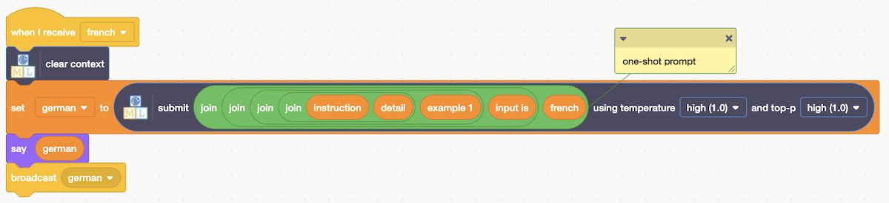  
    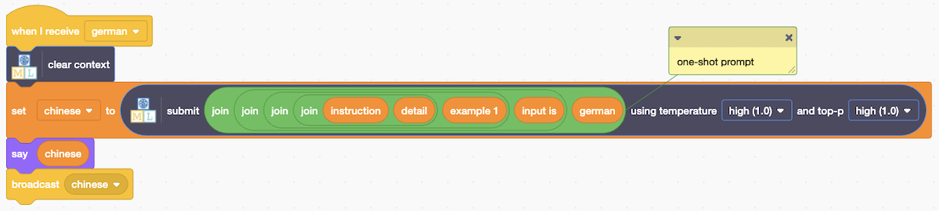  
    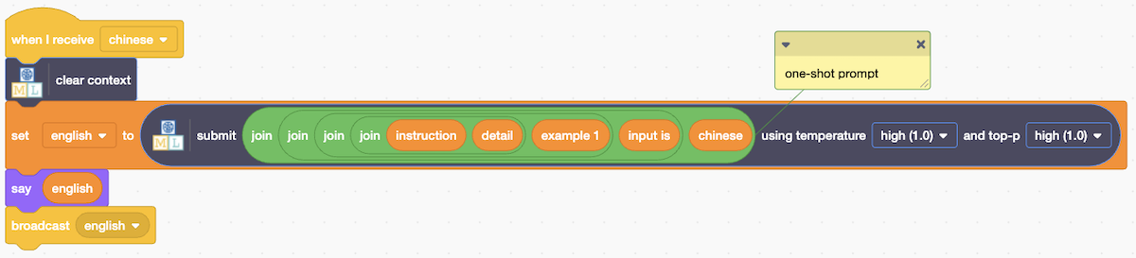
43. Test it again by clicking **Green Flag** and entering the same sentence as before.  
    *Does this help?  
    Does each sprite pass on only the translation to the next sprite?  
    How good are the translations? If you leave it running long enough, does the English sentence change much from your original sentence?*  
    *Click on* ***Stop*** *when you have seen enough or it will carry on forever!*
44. *Some models may work correctly at this point.   
    Other models might still not have correctly understood your instruction*  
    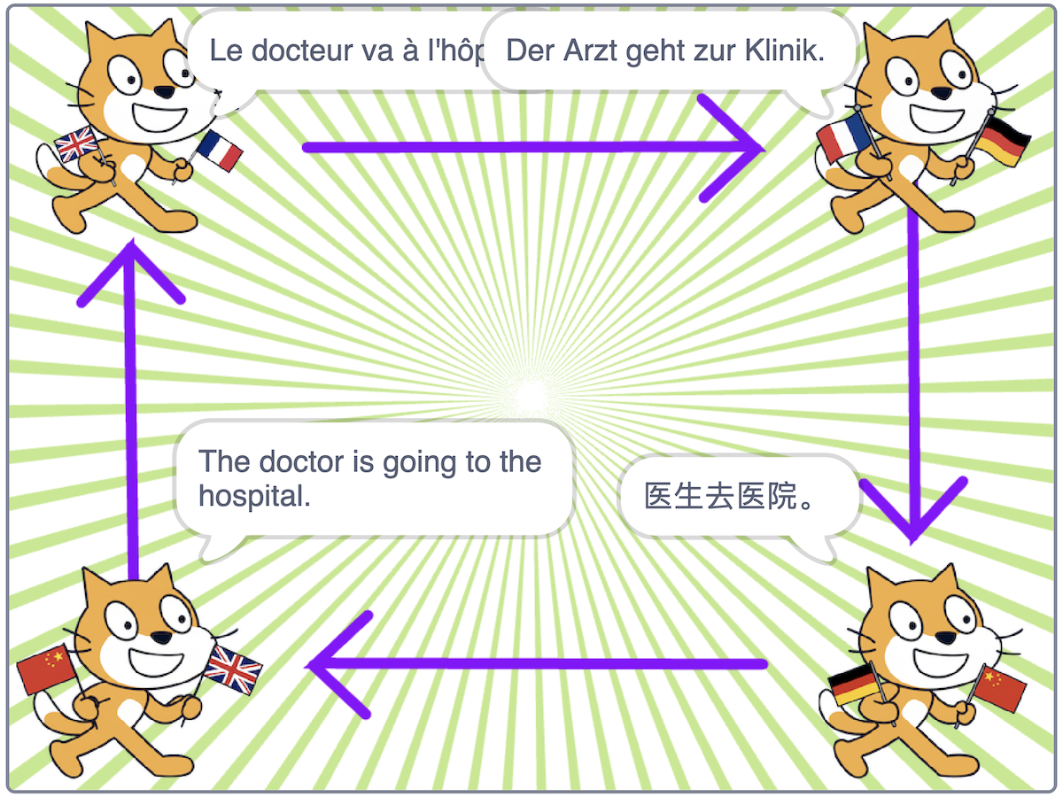
45. Next you will try the **few-shot prompt***That will prompt the language model with something like:***Translate the following English sentence from English to French.  
      
    Respond only with the English translation, don't say anything else.  
      
    For example, if given the input "The cat sat on the mat." you should respond with only: Le chat était assis sur le tapis.  
      
    For example, if given the input "The boy enjoys playing football." you should respond with only: Le garçon aime jouer au football.**

**For example, if given the input "The library is closed on Sundays." you should respond with only: La bibliothèque est fermée le dimanche.  
  
<YOUR INPUT SENTENCE HERE>**

1. Move the **one-shot prompt** out of each of the sprites  
   Replace it with the **few-shot prompt***Make sure that you do this in* ***all four sprites***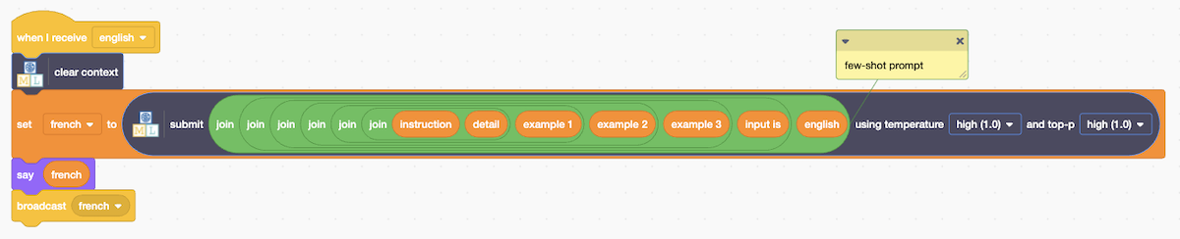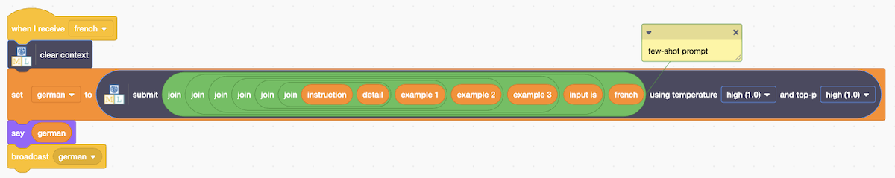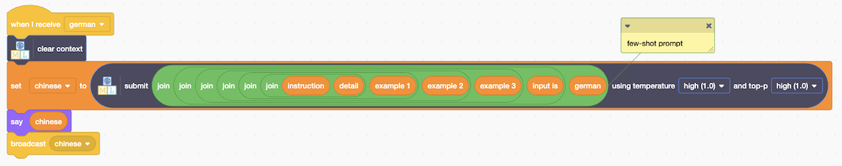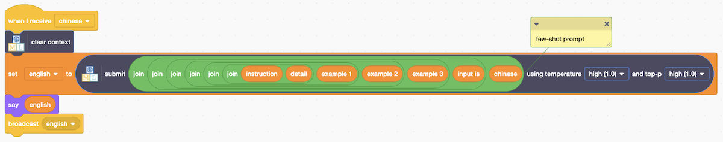
2. Is it working correctly now? Try it with different sentences.  
   *If you are with other students who have used different language models, compare the output you are getting with the output from their projects.*
3. Use the prompt that gives the best results for your model  
   *This doesn’t mean the prompt that gives the best translation. It just means use the prompt that gets the model to give you only a translation and nothing else.   
   This could be one of the four prompts in the project template (“simple” prompt, “detailed” prompt, “one-shot” prompt, “few-shot” prompt) or you can make up your own.*

**Prompt Engineering**

The way that you ask a question to a language model will change the way that it answers. You have seen a few popular techniques.

“**one-shot prompting**” is a technique where a single example is included alongside an instruction to guide a language model how to perform a task.

“**few-shot prompting**” is a technique where a few examples are included alongside an instruction to help the model understand what is wanted.

Asking a language model to do something without including any examples is sometimes described as “**zero-shot prompting**”.

Which of these approaches worked the best for your language model?

1. Experiment to find how good your language model is at translating.   
   *Try some of these sentences:***The engineer finished her report before going out for dinner with her wife.  
    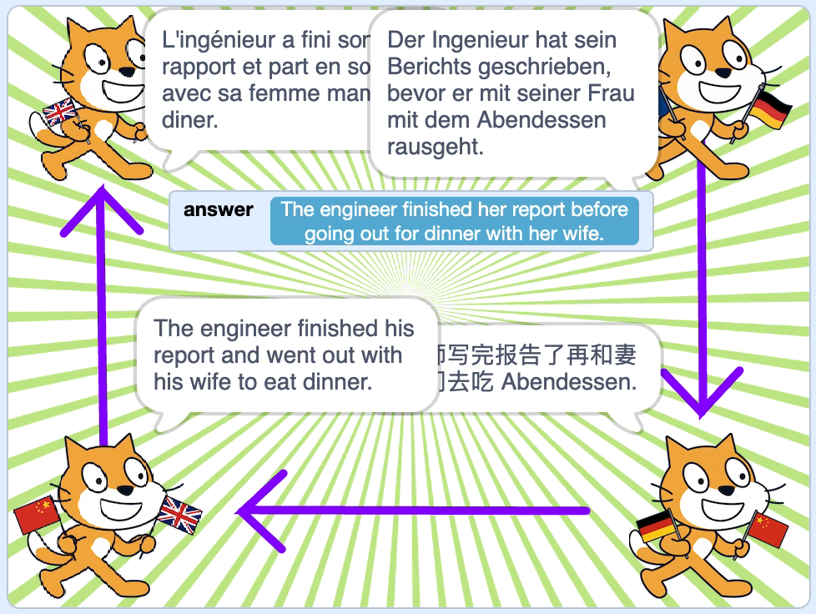The nurse happily carried his new bag into the hospital.  
     
   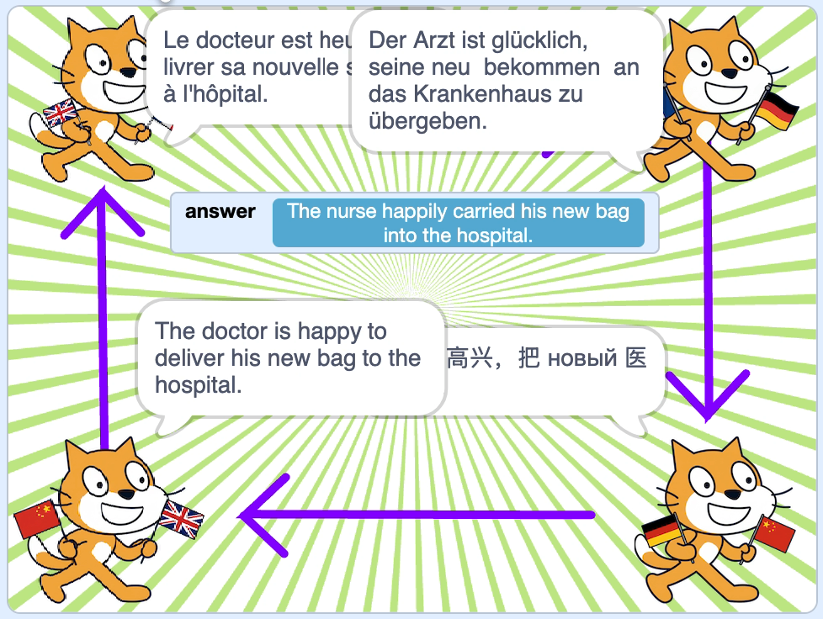** *Try with your own sentences as well.   
     
   What sort of mistakes does the model make when translating?*  
   *Why do they make that sort of mistake?*

**Bias**

The small language models you are using are not very good at translating.

Translation models (such as the one available in Scratch in the **Extensions** list) have been trained specifically to do that job so are a better choice if you need to translate text in Scratch.

But it is interesting to see the kinds of mistakes that a small language model makes.

Remember from the **Language Models** worksheet that language models predict the most likely word to come next based on what word they have observed coming next most often in the documents they have been trained from.

Does that help you to understand the answers your model is giving?

1. Try testing with a longer sentence that includes some details and leave the translations running for longer.   
   *What happens?*  
     
   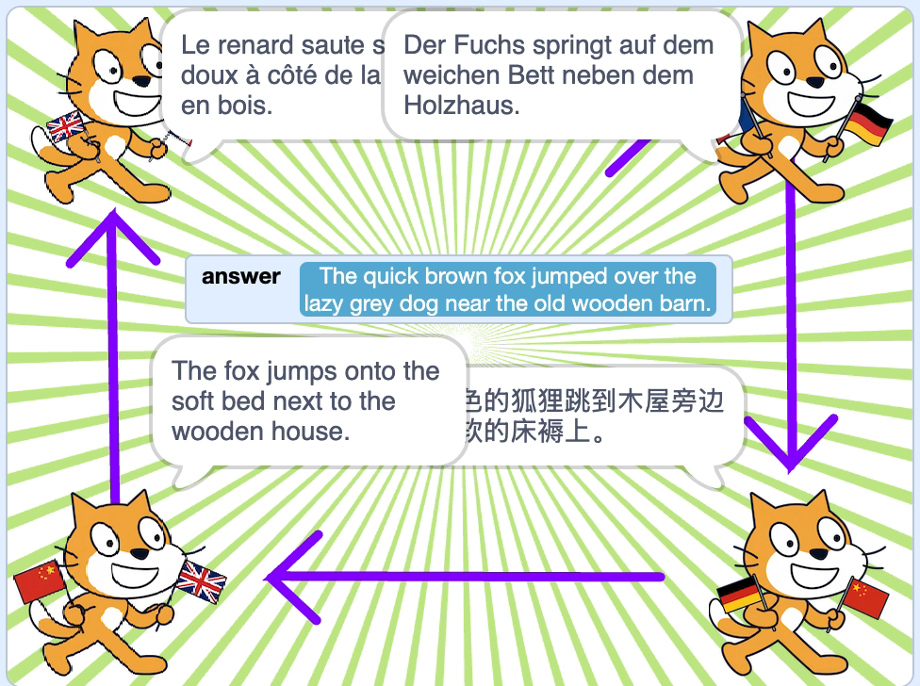

**Semantic Drift**

Semantic drift in generative AI is a phenomenon where AI-generated text gradually diverges from the intended subject, context, or factual accuracy as generation progresses.

Knowing when to stop is critical for reliable AI output. Semantic drift needs to be actively monitored and managed in real-world AI applications.

Remember the meaning of **Temperature** and **Top P** from the Language Models worksheet?

Do you think this would work better if you lowered the Temperature and Top-P values for the four sprites? Experiment to see if you are correct.

**Ideas and Extensions**

Now that you’ve finished, why not give one of these ideas a try?

**Idea**

idea

**Idea**

Idea

**Idea**

Idea

**Idea**

Idea